Chenqiushi
James Otyle
Ela 2.5
2026.6.1

The land

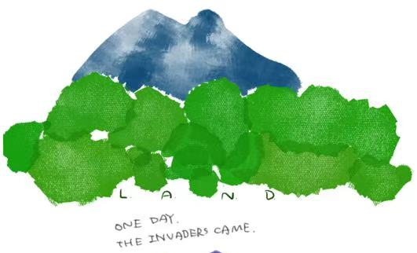

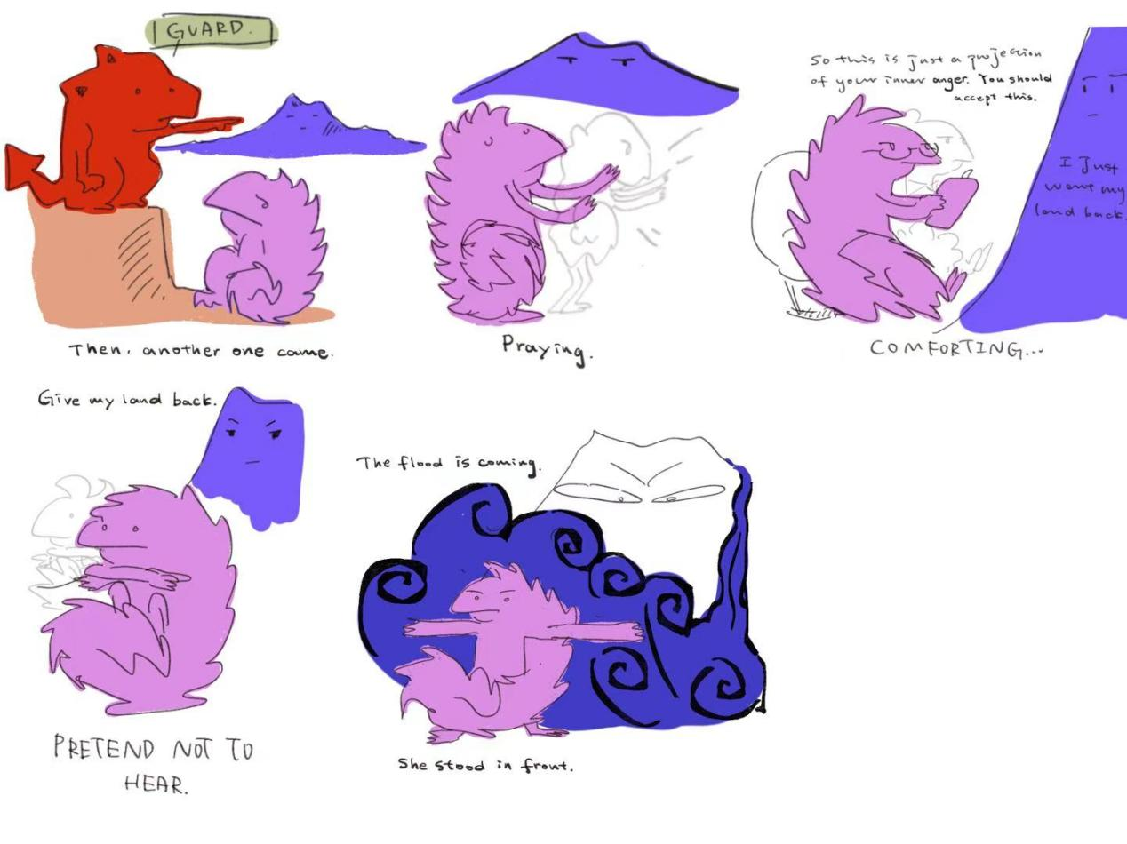

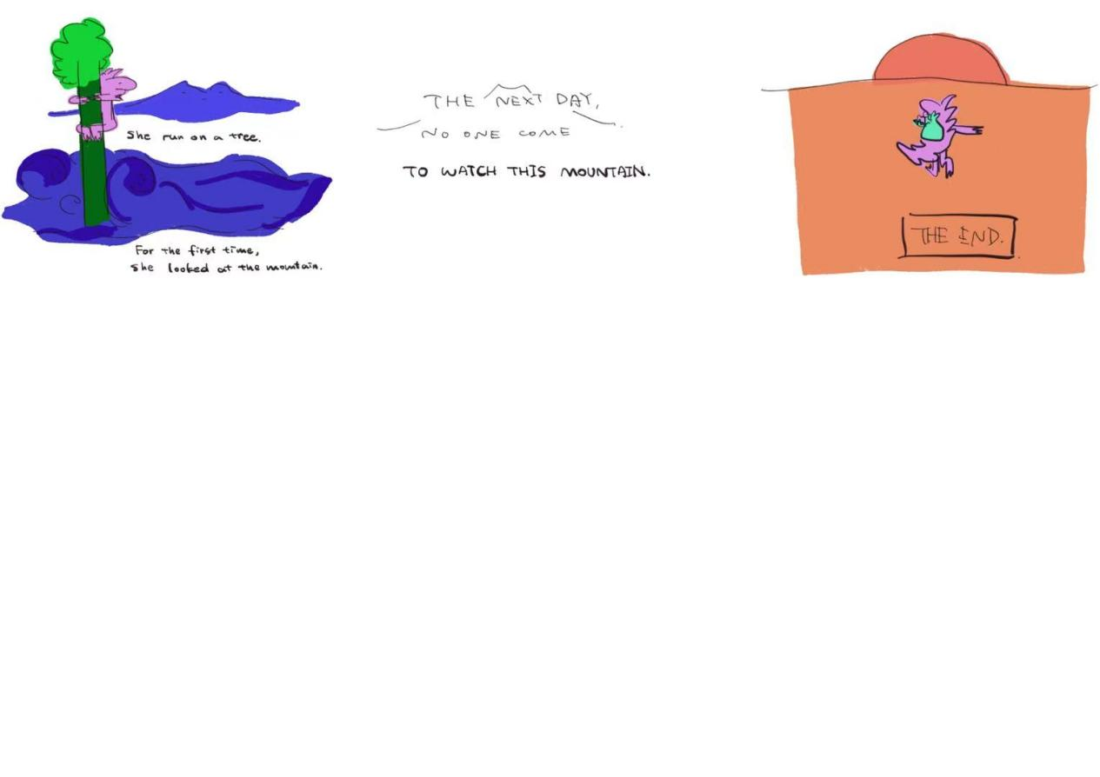

Process piece
My academic paper explores how "revenge" in Wuthering Heights is constructed as the narrative center, and how this centralization ignores women’s stories. I would like to know that what would an obscured sound look like if it had a visual form?
I want to show not a simple victim/perpetrator opposition, but a more complex position. Some are trapped and excluded, yet still maintain the order that excludes them. In Wuthering Heights, little Catherine and Isabella were oppressed but eventually escaped. Nelly is the oppressed guardian who maintains order. My lizard mountain keeper occupies precisely this contradictory position: it is expelled from the mainstream, but also becomes a conspirator of the colonial system.
I tried to use a human character first, but it would need more time to explain why a certain person was excluded from the mainstream. So drawing a lizard and use different colors to seperate them is more obvious.
The reincarnation mechanism shows the novel’s core structure: generational trauma repeats, and reality blurs with memory. My lizard prays, pretends not to hear the mountain, and offers empty comfort.This corresponds to Catherine’s behavior in the book. Critics saw her madness, hunger strike, and death, but not the real problem. She had no inheritance and could not live independently. She didn’t go crazy for love; she was forced to die by a society with no place for her.
My theme is : how do those who are expelled keep cycling in maintaining the system that oppresses them until someone chooses to leave. The pale lines are the mountain’s memories of previous lizards. They are so similar that they blur together. The lizard was trying to protect the village when the flood came represents Nelly was actually maintaining the current situation while she was also being oppressed. The ending with no lizard comes represents escape, just like Isabella also escapes. I want the readers to feel like some sene looks like it happens before, like it was repeating.

